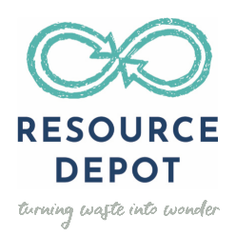
ELO Program Name: REimagine Our World: Conservation through Creativity
About Resource Depot
For over 20 years, Resource Depot has tackled Palm Beach County’s growing waste problem by rescuing unwanted and excess materials, turning waste into wonder. Resource Depot not only collects materials but works to change people’s minds and habits to have less of a negative impact on the environment. Resource Depot keeps hundreds of thousands of pounds of reusable materials out of the landfill each year – materials such as carpet squares, paper of all sizes and colors, wallpaper sample books, tiles and tile samples, office supplies and craft materials such as buttons, ribbon, yarn, or beads. Every day, Resource Depot encourages others to have fun with diverse materials, inspiring children, and adults to express themselves through creating. Resource Depot serves as an inspiration and resource to Palm Beach County’s next generation to value and care for the planet they’re inheriting through reuse and repurposing.
Description of our ELO Program
REimagine Our World: Conservation through Creativity consists of six one-hour hands-on environmental art lessons designed to engage kindergarten through eighth grade youth in creative, collaborative projects demonstrating the “who/what/why” of creative reuse. Participants learn about the four R’s (Reduce, Reuse, Recycle and Rethink) and how pollution and overconsumption affect us and our environment. Participants will creatively use discarded materials in art projects/games to rethink items they throw away and apply knowledge gained in the discussion. Resource Depot (RD) provides direct, in-person instruction and all associated materials. In each session, youth participate in the discussion and hands-on learning to:
- Discover how the waste cycle in which they actively participate can be disrupted by conscious, positive actions;
- Reflect on/evaluate their consumption habits, learning strategies to reduce the number of materials in the waste stream;
- Take ownership of the planet and recognize their actions’ relationship with the environment and each other.
- Express creativity through hands-on art projects/games with open-ended materials, integrating academic areas (such as language arts, STEM and civics) while respecting the ideas of others.
- Gain perspective of the origins – and limitations – of natural resources and consumer goods through discussion and creating with “disposable” items as art materials.
- Identify optimistic, action-based steps towards environmental solutions, of which they can be leaders.
Site Agreement Form
By signing this form, you are agreeing to participate in Resource Depot’s REimagine Our World: Conservation through Creativity. Please return the completed form via email to the Teaching Artist you are working with before you can book.
Site Eligibility Requirements:
- Must have a minimum of 15 youth per session to participate and no more than 25. No high school students in groups. Elementary and Middle School students must be in separate groups.
- Have a designated adult present during each session.
- Secure approval from Prime Time before the ELO session begins.

Site Responsibilities: Name of Site:
Sites must notify Teaching Artist (TA) before a session starts if there are not enough students present to conduct class. Resource Depot cannot serve you if there are less than 15 students. This is a grant funded program, so your Site gets this ELO at no cost, normally for these services Resource Depot would charge the Site $50-$175 per class.
- All Sites must have the Parent Guardian Consent form signed for all students participating in our program, before begin our sessions.
- Resource Depot is not responsible for making youth behave. Site staff are responsible for the behavior of youth in the program.
- Site staff should be just as engaged as the students during the ELO and all cellphones/I-Pads should not be in use during the ELO.
- The site will provide an adequate space for the TA to conduct each session.
- The site may be responsible for providing the TA with access to Wi-Fi, video, presentation and or audio equipment. (this would be discussed beforehand)
- Site staff will provide a list (digital or printed) of students (with first name, last name, and grade) prior to a session starting, and help with attendance records during each session.
- Provide a minimum of 24 hours’ notice to cancel or reschedule sessions.
- Complete a survey https://www.resourcedepot.org/pt-survey immediately following the service provided. The survey link will remain the same throughout the 2022-2023 program year. We recommend bookmarking it on your browser so that you always have it handy, but please also remain alert to reminder emails.
- We love to share what we do, if have an image you want to share with us be sure to tag us on social media, so students can be part of the online gallery. @TheResourceDepot @ResourceDepot
ELO Responsibilities:
- Resource Depot (RD) will provide 1 hour of quality out-of-school time instruction for each of the 6-session scheduled.
- RD Teaching Artists (TA) will have lessons ready for each session, and bring all materials needed, and will make sure the site space is left as it was found.
- RD TA will document their projects and session by taking pictures, no images of students’ faces will be used unless we have permission.
- RD TA must verify that all attendance sheets and reports are complete and accurate before leaving the site after each session. Note: Each attendance sheet should have the following:
Date of session and Full Name of Site
Total # of students in each session
Each child’s first name, last name, and grade
- RD TA’s will provide a minimum of 24 hours’ notice to cancel or reschedule sessions.
- RD will keep up to date with training and OST feedback in order to provide the best service possible.
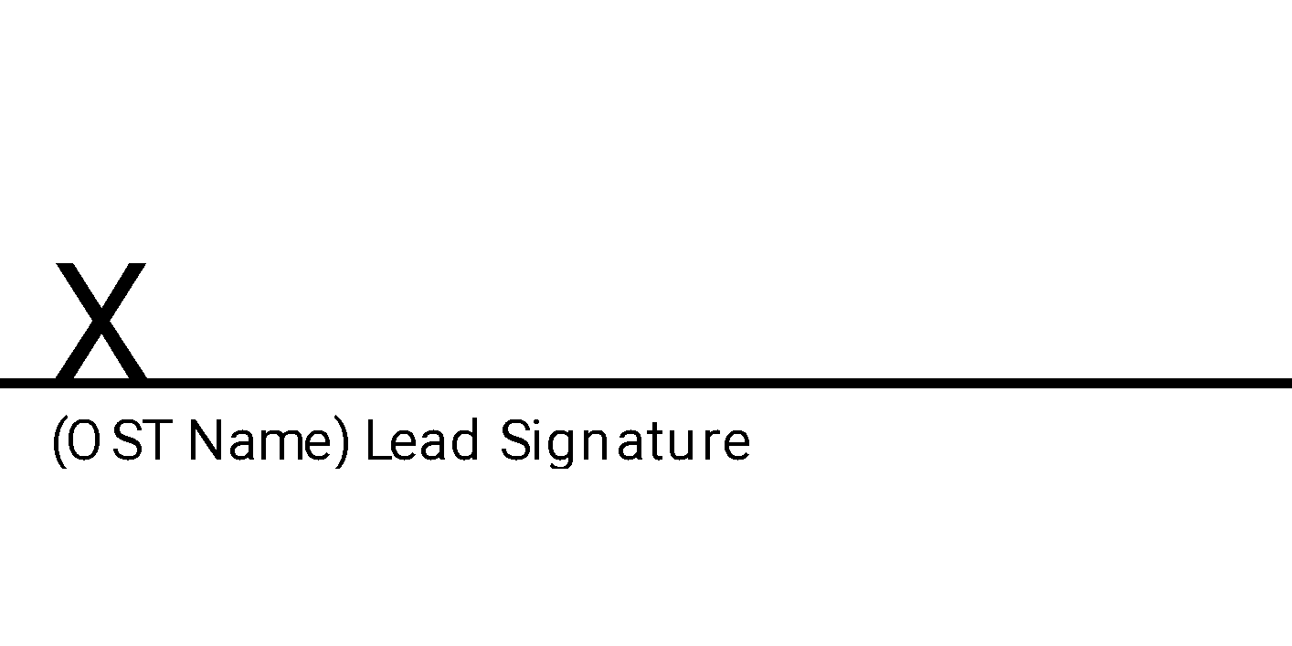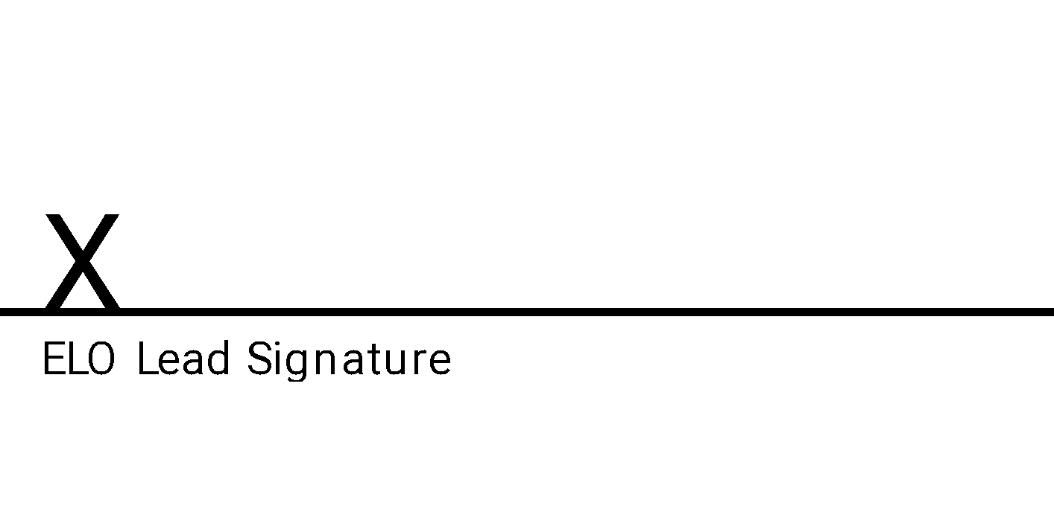

ELO Contact Information
Director of Education & Artist Relations at Resource Depot: Chelsea Odum
Contact Phone Number: 561-882-0090 ext. 102
Contact Email Address: codum@resourcedepot.org
Resource Depot Teaching Artist Name: Janice Henn
Contact Phone Number: 561-635-6381
Contact Email Address: janicehenn423@aol.com
Resource Depot Teaching Artist Name: Shirley Rose
Contact Phone Number: 561-860-1487
Contact Email Address: shirleygirl1121@gmail.com
Resource Depot Teaching Artist Name: Connie Riblet-Hill
Contact Phone Number: 561-506-6595
Contact Email Address: cjribhill@gmail.com

